Placement IQR Report

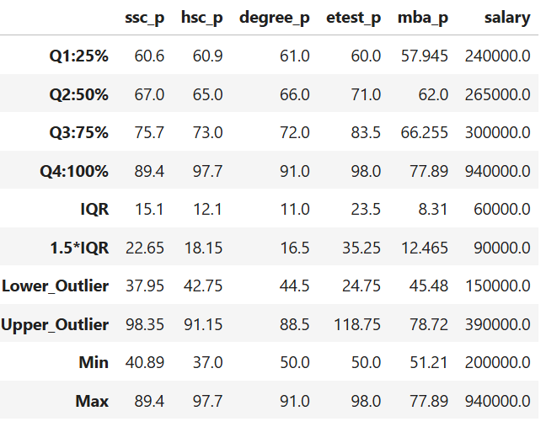
SSC Percentage (ssc_p)
Q1 = 60.6
Q3 = 75.7
IQR =75.7 − 60.6 = 15.1
1.5 × IQR =1.5 × 15.1 = 22.65
Lower Outlier = 60.6 − 22.65 = 37.95
Upper Outlier = 75.7 + 22.65 = 98.35
Min=40.89
Max=89.4
- There are no potential outliers in ssc_p
HSC Percentage (hsc_p)
Q1 = 60.9
Q3 = 73.0
IQR=73.0 − 60.9 = 12.1
1.5 × IQR=1.5 × 12.1 = 18.15
Lower Outlier=60.9 − 18.15 = 42.75
Upper Outlier=73.0 + 18.15 = 91.15
Min=37.0
Max=97.7
- There are some potential outliers in hsc_p since Min < Lower Outlier and Max > Upper Outlier.
Degree Percentage (degree_p)
Q1 = 61.0
Q3 = 72.0
IQR=72.0 − 61.0 = 11.0
1.5 × IQR=1.5 × 11.0 = 16.5
Lower Outlier=61.0 − 16.5 = 44.5
Upper Outlier=72.0 + 16.5 = 88.5
Min=50.0
Max=91.0
- There are some potential outliers in degree_p since Max > Upper Outlier.
Entrance Test Percentage (etest_p)
Q1 = 60.0
Q3 = 83.5
IQR=83.5 − 60.0 = 23.5
1.5 × IQR=1.5 × 23.5 = 35.25
Lower Outlier=60.0 − 35.25 = 24.75
Upper Outlier=83.5 + 35.25 = 118.75
Min=50.0
Max=98.0
- There are no potential outliers in etest_p.
MBA Percentage (mba_p)
Q1 = 57.945
Q3 = 66.255
IQR=66.255 − 57.945 = 8.31
1.5 × IQR=1.5 × 8.31 = 12.465
Lower Outlier=57.945 − 12.465 = 45.48
Upper Outlier=66.255 + 12.465 = 78.72
Min=51.21
Max=77.89
- There are no potential outliers in mba_p.
Salary
Q1 = 240000
Q3 = 300000
IQR=300000 − 240000 = 60000
1.5 × IQR=1.5 × 60000 = 90000
Lower Outlier=240000 − 90000 = 150000
Upper Outlier=300000 + 90000 = 390000
Min=200000
Max=940000
- There are potential outliers in salary since Max > Upper Outlier.

